Decription about the building, which is suitable for business (for rent or for coorperation to make business together)

Building characteristics
Address (place) | Respublikos str. 113, Rokiškis
Property | Private
Detaided and special plan | Yes
The current building usage purpose | Industrial-storehouse (warehouse)
Planned building usage purpose according to the documents of territory planning | Industrial-storehouse (warehouse)
Building area (sq.m) | 5400
State of the building | Satisfactory
Neighbouring territories | Industrial zone
Exploitation | Yes
Infrastructure
Communication infrastructure:  Trunk-roads, regional roads, local roads (streets) | Asphalt road. There is big asphalt car parking near the building.
Engineering infrastructure:  Water supply  Waste water  Electricity networks  Street lighting  Heating networks | +  +  +  +  +
Contact person: Rimgaudas Kilas, mobile phone: 8-686-00695

Photos:

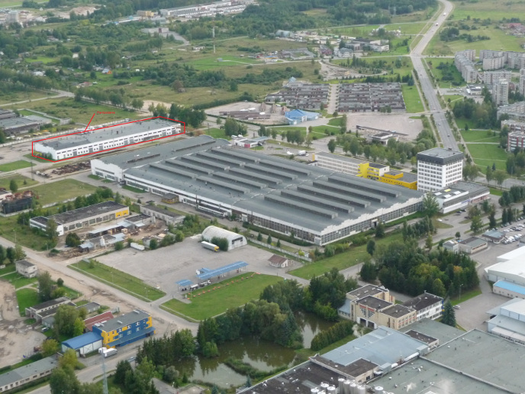
Nuoma, bendra veikla

